Level 1

Module 1

Anchoring and Submodalities

Embedded Commands/Analogical Marking

This is where you mark out certain words for your patients unconscious mind (words such as “relax” for example).

The word would appear in normal conversation, such as
“You can allow yourself to relax”
but you would mark the chosen word out in some way…

You can do this through…

- Changes in volume: such as saying certain words louder or quieter
- Small gaps in the sentence either side of the word

- Gestures: even with their eyes closed the patient will still unconscious pick up on this

- Deletion: missing out an obvious word so the person fills in the word for themselves and so making it stand out more

- Changing the direction of your voice: for example speaking slightly to their side, and then when you say the chosen word saying it directly at them

A Reminder about Representational Systems – or Modalities

We have three main modalities through which we experience the world:
Visual
Auditory
Kinaesthetic

We tend to have one favoured system of how we interpret and behave in the world.

People who are:

Visual:

Stand or sit upright with an erect spine
Eyes move above centre
Higher pitched, loud, fast and clear speech
Breathe at top of lungs
Neat, tidy and well groomed
Good at memorising visual instructions

Auditory:

Move their eyes from side to side
Breathe from the middle of their chest
Talk to themselves
Easily distracted by noise
Can repeat words exactly
Like talking on the phone and listening to music
Memorise things by steps, procedures and sequences
Sensitive to tone of voice

Kinaesthetic:

Breathe from the bottom of their lungs
Lower pitched, slower and quieter voice
Move slowly and deliberately
Respond to touch and physical reward
Stands closer than a visual person
Memorise by doing and talking through the steps

Auditory digital:

Talk to themselves
Learn by making sense of things
May experience tension in neck and shoulders
Can take on characteristics of other systems

To gain rapport with people, we need to be able to enter their world. One of the ways of doing this is to use predicates that are appropriate to their experience (this is a more detailed way of getting rapport through words).

Visual | Auditory | Kinaesthetic | Auditory Digital
See | Hear | Feel | Sense
Look | Listen | Touch | Experience
Appear | Sound | Grasp | Understand
View | Sounds | Get hold of | Think
Show | Make music | Slip through | Learn
Dawn | Harmonise | Catch on | Process
Reveal | Tune in/out | Tap into | Decide
Envision | Be all ears | Make contact | Motivate
Illuminate | Rings a bell | Throw out | Consider
Twinkle | Silence | Turn around | Change
Clear | Be heard | Hard | Perceive
Foggy | Resonate | Unfeeling | Insensitive
Focused | Deaf | Concrete | Distinct
Hazy | Dissonance | Scrape | Conceive
Crystal clear | Overtones | Get a handle on | Know
Flash | Unhearing | Solid | Question
Imagine | Attune | Suffer | Be conscious
Picture | Outspoken | Unbudging | Logic
Sparkling | Tell | Impression | Reasonable
Snapshot | Announce | Touch base | Statistically
Vivid | Talk | Rub
Perceive | Speak | Smooth
Light | State | Pushy
Ray | Whine | Stumble
Mesmerise | Babble | In touch
Watch | Echo | Relaxed
Frame | Orchestrate | Loose
Shine | Whisper | Cool
Dim | Snap | Tepid
Image | Hum | Heavy
Vision | Loud
Observe | Dialogue

Eye patterns:

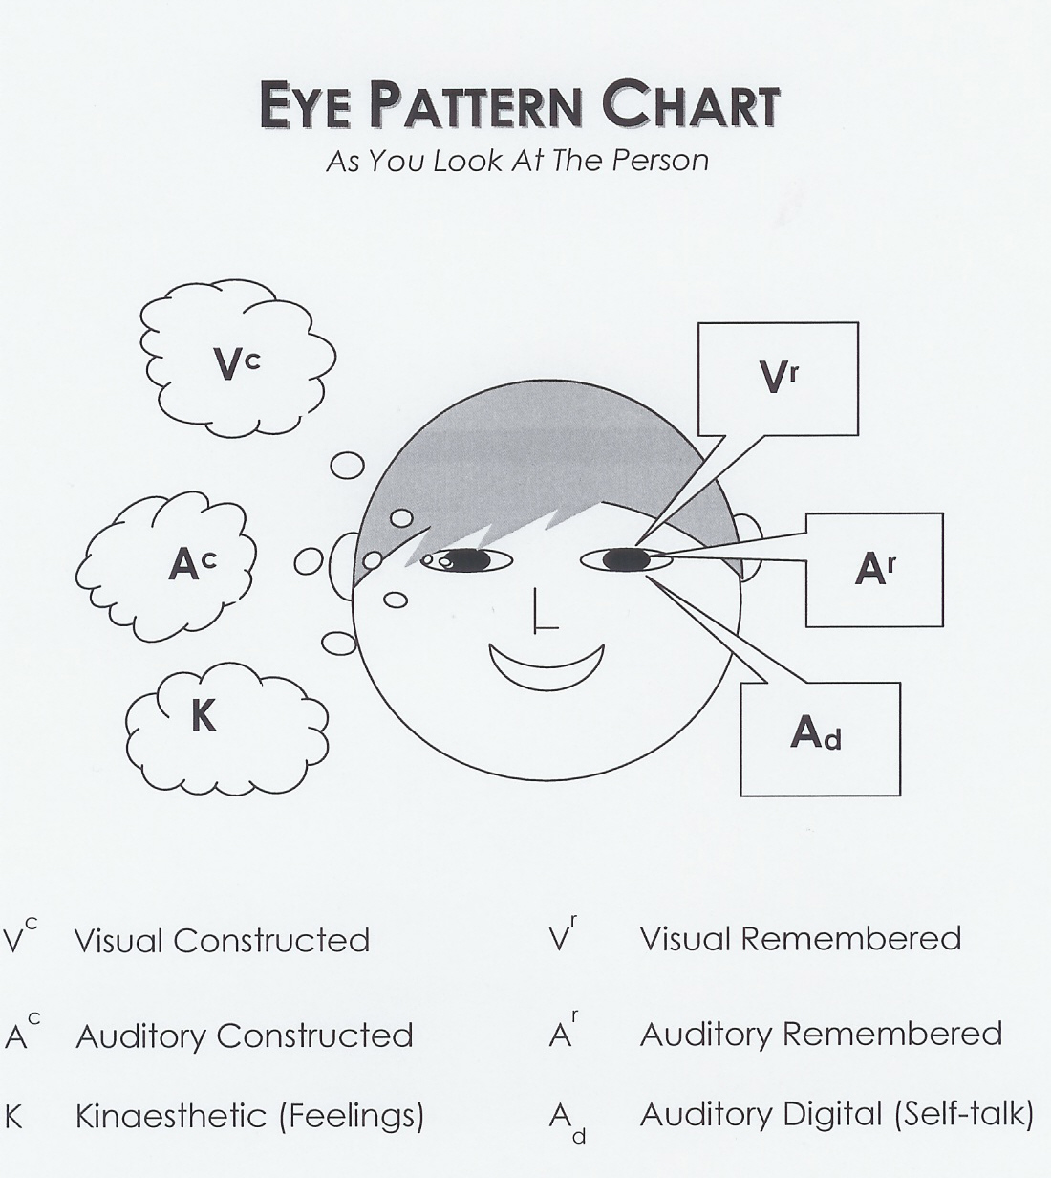
Eye Pattern Elicitation Questions

These questions are useful questions to ask to notice how people’s eyes move in response to them

Visual remembered:

What was the colour of your first bike?
What was the colour of your childhood best friend’s hair?

Visual construct:

What would your bike look like now if you painted it fluorescent pink?
How would your best friend look with green hair?

Auditory remembered:

What was the last song you listened to?
What is your favourite song of all time?

Auditory construct:

What would I sound like with Mickey Mouse’s voice?
How would your favourite piece of music sound played by Marilyn Manson and Eminem?

Auditory digital:

What was the first thing you said to yourself this morning?
Play the last conversation you had with a loved one inside of your mind?

Kinaesthetic:

What does it feel like to walk in warm sand?
How does it feel to have a relaxing massage?

Submodalities
are
Finer distinctions of the major modalities

Submodalities are one of the most famous components of NLP, and perhaps one of its most unique offerings.

Submodalities code, order, and give meaning to, our internal representations.

Modality use is everywhere in our experience…
- “She just tunes me out”
- “I don’t see any alternative”
“I’m trying to come to grips with the problem”

Submodality use is just as prevalent…
- “I need to get some distance from the problem”
- “I want to get things in perspective”
- “This is so cool”
- “Things are heating up in here”
- “This whole thing is a real headache”
- “I’m really starting to get some clarity on this”

Drivers:
- A specific Submodality which, if changed, will change all the others
- Often Location and Association/Dissociation are drivers

Visual | What picture comes to mind?
Black and white/colour
Near or far
Bright or dim
Location
Size of picture
Associated or dissociated
Focused or defocused
Focus – Changing/steady
Framed or panoramic
Movie or still frame
Movie – Fast/Normal/Slow
Amount of Contrast
3D or flat
Angle viewed from
Number of pictures (shift?)
Auditory | What sounds are important?
Location
Direction
Internal or External
Loud or Soft
Fast or Slow
Pitch – High or Low
Tonality
Timbre
Pauses
Cadence
Duration
Uniqueness of Sound
Kinaesthetic | What feelings are important?
Location
Size
Shape
Intensity
Steady
Movement/Duration
Vibration
Pressure/Heat
Weight

Visual | What picture comes to mind?
Black and white/colour
Near or far
Bright or dim
Location
Size of picture
Associated or dissociated
Focused or defocused
Focus – Changing/steady
Framed or panoramic
Movie or still frame
Movie – Fast/Normal/Slow
Amount of Contrast
3D or flat
Angle viewed from
Number of pictures (shift?)
Auditory | What sounds are important?
Location
Direction
Internal or External
Loud or Soft
Fast or Slow
Pitch – High or Low
Tonality
Timbre
Pauses
Cadence
Duration
Uniqueness of Sound
Kinaesthetic | What feelings are important?
Location
Size
Shape
Intensity
Steady
Movement/Duration
Vibration
Pressure/Heat
Weight

Submodality Crossover Pattern

- “What food or drink comes to mind that you currently like but wish you did not – OR that you currently don’t like but would like to be able to eat/drink more easily?”

- “What food or drink comes to mind that is similar?”

- Elicit the Submodalities of both – breaking state between the two. (It makes sense to elicit the Submodalities of the one you wish to make the changes to second)

- Do contrastive analysis on the two sets of Submodalities. Then change the Submodalities of the food wish to change into the Submodalities of the food they wish to change it to. KEYS: Note the drivers (the submodality that when changed, changes the whole experience); use their words and ensure to use your language to help them to change ‘state’.

- “As you think about that food that you used to think you liked, what happens?”

- Future pace

Anchoring

State and State elicitation

States are: the sum of everything that is going on at a conscious and unconscious level, in our thinking, emotional process and physiology.

Key elements of a state:

- Our internal VAKId: Visual, auditory, kinaesthetic and internal dialogue representations – so what we are feeling, hearing inside, seeing in our minds, telling ourself……

- Our physiology

By paying attention to these factors, we can establish how we are creating any state – and its physiological effect – and therefore how to change it.

States are essential to understand in managing and directing our own experience, and also are a key part of any NLP practitioner work, since the state we are in dictates so much of our behaviour.

State elicitation:

A key part of many NLP techniques is state elicitation – helping a client to access a specific state with the aim of changing a current issue in some way.
Questions for eliciting a state:

- Can you remember a specific time when you felt completely/totally……….? (calibrate their physiology to assess when they seem to connect back into that time….)

- Go back into that time now, float right into that time, hearing what you heard, and seeing what you saw, feeling the feelings of being completely……………now.’

Associated/Dissociated:

There are two ways of remembering an experience – which can be helpful or unhelpful at different times, but both of which we will use unconsciously in recalling past experiences.
Associated: being really in the experience – seeing, hearing, feeling those feelings. We will know that it is not current reality, because we have the ability to differentiate the present and the past, so it will not feel entirely REAL! This is important, as sometimes our expectations of going into states can be unrealistic.
But in this state, we will be able to access how we felt quite easily – this is the state in which we are when we feel either good or bad about the past.

Dissociated:

This is when we are outside of the experience – observing, almost. For some people, we observe all the time and are dissociated in our own lives. Others find it hard to really engage with memories because they cannot connect to the feelings they felt then.

When dissociated/associated can be helpful:

Associated: to connect to past positive experiences, where we were resourceful; to fully experience and enjoy the present

Dissociated: when we would like to create distance from an experience which continues to trouble us – think post traumatic stress.

In NLP techniques, we will sometimes want to encourage clients to associate, sometimes to dissociate, but the rule is: if it was resourceful, positive and enjoyable – then associate. If it was stressful, painful or traumatic – dissociate.

Perceptual Positions:

A concept used a great deal in Gestalt and Transactional Analysis, this is the ability to take different viewpoints.

These are:
1st position: your own view (associated)
2nd position: the point of view of someone else (dissociated)
3rd position: The point of view of an outside observer (double-dissociated)

We use these all the time – those who are most successful at empathising, resolving conflicts, seeing outside the box, for example, are very skilled at taking these different perceptual positions.

Consciously choosing to take a different position, or helping a client to access a different viewpoint can be a very helpful reframe.
Anchoring
is
Creating an artificial association between two things that are not necessarily associated

4 steps to anchoring:
- Elicit an intense associated state in the client
- Provide a unique stimulus as the state reaches its peak intensity
- Break the state with the client so that their state changes
- Test the Anchor by providing the same stimulus and notice what happens

The 5 keys to successful anchoring:
- The client must be in an intense state
- The Anchor must be applied at the peak of the state
- The stimulus used for the Anchor must be unique
- The Anchor must be repeatable
- The more times the Anchor is created the better the Anchor

Preferred states for anchoring (in order of preference):
- Naturally occurring states
- Vividly remembered, specific memories from the past
- General memories from the past
- Imagined or constructed states

What times come to mind when you have felt…

- Truly loved

- A deep sense of peace

- Total confidence

- A sense of inner power

Setting an Anchor

- Connect with your client and explain what you are going to do

- Go into the desired state yourself

- “What time comes to mind first when you were totally X’d?”

- “What was it about that experience that most made you feel X’d, and where in your body did that feeling start?”

- “As you go back to that time now… go right back to that time, float down into your body and see what you saw, hear what you heard, notice what you noticed and really feel the feelings of being totally X’d”

- Continue to talk them through the experience (can be useful to ask, “On a scale of 0-10, 10 being the most powerful feeling this could possible be, what number is it at the moment?”)

- Anchor it

- Ask them to open their eyes and let go of the feeling

- Test the anchor – if it isn’t as strong as you’d like, go back to step 5. A useful question here is, “As I press that anchor now, how quickly do those feelings of… come back?”

Current State-Desired State

- Connect to the client

- Find out the details of what/when/how they want to be different. Elicit three to four different anchors which would help them do that

- Set the anchors in different places

- Have the client imagine going to a movie theatre inside their mind, in that situation, but with you firing the anchors

- Try before you buy: Ask: “As you see yourself being this way now, is this exactly the way you would love to be, or is there anything else we can add to make these even more powerful for you?” If perfect as it is, go to step 6, otherwise go back to step 2 and find out other resources they would like, or fine tune the quality of the ones you have

- Have them associate into the movie: Ask: “As you sit there now, allow yourself to float into that movie screen, and become that new you. Notice what you see out of your own eyes, the sounds you hear, and just how good it feel to be this new way….” continue running through with hypnotic language all the way to the end

- Future pace (have them imagine the changes going into the future)

Other Ways of Working with Anchors

Stacking anchors: where you “stack” a number of anchors on top of each other by anchoring them in the same place. The result is creating an extremely strong anchor

Collapsing: When two different anchors are fired off at the same time, they combine their states. If one of the states is the opposite of the other one, they cancel each other out. If you want to delete an anchor, set up an anchor for the opposite feeling and fire them off simultaneously. Generally speaking, the stronger of the two anchors will always win, so make sure the “positive” anchor is at least as strong as the “negative” one.

Chaining: chaining anchors is used to move someone between two states where jumping from one state to the other would be too bigger jump. You therefore elicit appropriate states in between, anchor those, and then take the person gradually through the anchors. For example, if you wanted to take someone from depression to excited, you might have:

Depression

Openness to change

Curiosity about a better life

Excitement

